**Phase 1**

**Output:**

Assume the following:

* Capable of outputting 40,000 capsules per hour, maximum’
* Operate at efficiency, η, 0.5
* We operate 24 hours a day, 300 days a year.
* Each capsule weighs 2g

$$\frac{40,000 capsules}{hr} x 0.5 x \frac{24 hr}{day} x \frac{300 day}{year} x \frac{2 g}{capsule} x \frac{1 kg}{1000 g} x \frac{2.2 lbs}{kg} x \frac{1 year}{12 mo} =52,800 lbs/mo$$

**Equipment Specifications:**

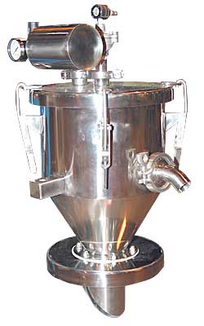*Vacuum Conveyor -*

The main piece of equipment required for the encapsulation unit operation is the vacuum conveyor manifold. This is required to push powder from the storage tank to the hopper of the encapsulater machine. This can be purchased from VAC-U-MAX and the specifications are below:

**Specifications:**

|  |  |
| --- | --- |
| *Capacity* | 200-250 Kg./Hr. |
| *Vacuum Source* | Original air-powered venturi, or electric blower |
| *Filter media* | Unique VAC-U-MAX Uni-filter |
| *Discharge Valve* | Full opening dump valve |
| *Inlet Size* | 1 1/2" inch |
| *Receiver Capacity* | .25 cu /ft |
| *Electrical Voltage* | 110/220 Volts, 50/60Hz., 1-phase |
| *Material of construction* | 304 stainless steel (optional 316L) |
| *Level Control* | Automatic level sensor |
| *Filter Cleaning* | Automatic pulse-jet |
| *Compressed air requirements* | 1/2" air line, 35 CFMQ60 PSIG |
| *System Control* | Solid state electronics in NEMA 4/12 enclosure |

<https://www.vac-u-max.com/product.cfm?cat=products-by-application&prod=vacuum-conveying-system-for-loading-tablet-presses>

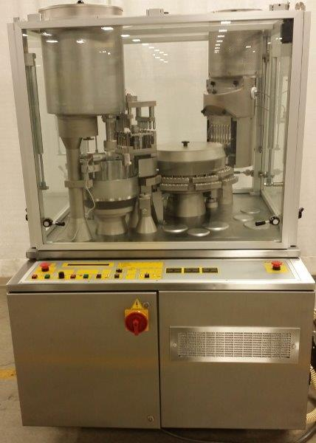*Automatic Capsule Filler –*

The capsule filler can fill up to 40,000 capsules per hour. However, we will probably operate at 50% capacity to allow for speed up and slowdown of our process. Most likely, this will be a rate limiting step in our process, as the powder flow can be easily scaled up. Thus, our powder flow design will be based off of the capsule filler.

**Specifications:**

Turret greased, Pneumatic Rectifier and Closing Station Pins replace with NEW, Disassembled and cleaned from top to bottom, Glass door replace in the back panel, Maximum Output (Capsule per hour): 40,000  
Serial #: 88051  
Electrical: V 415, ATM 6, KW 8.5, A 16, HZ 50 (can be adjusted to fit required 3 phase needs)  
Weight: 2,000 lbs

<https://www.labx.com/item/ima-zanasi-40-automatic-capsule-filler/4260094#description>

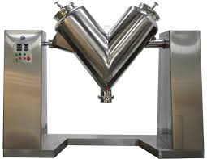*V-Cone Mixer –*

Mixing of the excipients with our product (the dried cells) is an essential part of our process. Proper mixing allows for uniform distribution of excipients and active ingredient, which will promote a consistent product for quality, safety, and adequate shelf life.

**Specifications:**

Mixer Type: Agitator

Product Type: Detergent Powder

Application: Powder

Additional Capabilities: Drying

Model Number: V-2

Max. Loading Capacity: 200L

Voltage: 220V 50HZ

Power(W): 5kW

<https://continentalrollomixer.com/buying-tools/compare-us-double-cone-v-blenders/>

*Process Resource Requirements –*

Other than energy, the main resource that I will is nitrogen (N2). This is utilized for the vacuum pump. It cleans out the vacuum filter after each cycle of the purging and release.

According to the approximate cycle time of the vacuum conveyor pump, the unit will require 288,000 L N2 every month.

This is also 360.3 kg N2 per month. This will cost us around $1000/mo.

*Alternatives to Encapsulation –*

Given our desire to have a dosage form of product, and that our active ingredient is bacterial cells, the only alternative to our encapsulation process would be tablet pressing and formation. Our general formulation would remain almost identical, however, instead of packing our product into a pill, we would press it into a tablet. See the figure below:

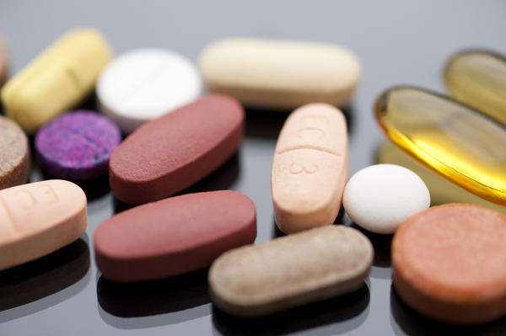

An advantage to this method is that we could increase our output substantially. Some tablet presses can push out 60,000 tablets per hour. This is a 50% increase from our capsule press. In addition, tablet presses are simpler and easier to maintain/cheaper to manufacture on occasion.

However, a main disadvantage is that our active ingredient is a cell. These cells need to stay viable in order for our product to work, and exerting our formulation to thousands of newtons of force could seriously decrease our product’s cell viability at the end of processing.